31th June, 2026

Authority Chief Executive
Nigerian Midstream And Downstream Petroleum Authority (NMDPRA)
Plot 1012 Cadastral Zone A00, Central Business District,
Abuja.

Attention: Head ICT

Dear Sir,

PROPOSAL FOR THE PROVISION OF TELECOMMUNICATIONS SERVICES – DATA SERVICE & MANAGED ICT SOLUTIONS
We are pleased to present our proposal for the provision of specialized telecommunication services to
Nigerian Midstream And Downstream Petroleum Authority.

PROPOSAL
We are pleased to propose the provision of our dedicated backbone connectivity infrastructure, complemented by our specialized managed ICT solutions, to support Nigerian Midstream And Downstream Petroleum Authority (NMDPRA) in achieving its
IT roadmap and expanding operational needs.
Our Wide Area Network (WAN) solution, aerial fiber-optic internet connectivity, and comprehensive ICT managed services are designed to optimize the Commission’s operations and processes to meet world-class standards. These solutions enable the secure transfer of large volumes of data, enhance the speed of information dissemination, and provide robust support for video streaming as well as seamless video conferencing across leading platforms such as Microsoft Teams and Zoom.

PROFILE
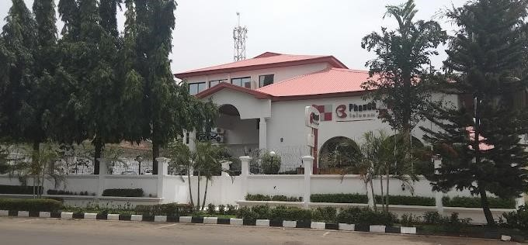
Phase 3 Telecom Limited is a neutral fiber transmission backbone provider and licensed National Long-Distance (NLD) telecommunications operator, delivering services across Nigeria and West Africa through its extensive aerial fiber network, recognized as one of the most reliable in the industry.
Incorporated in 2003 and licensed in 2004, Phase 3 entered into a concession agreement with the Power Holding Company of Nigeria (PHCN) to design, build, operate, and expand a robust optical fiber backbone along its high-voltage transmission lines.
Today, we operate a fiber optic network spanning over 10,000 km (and still expanding), deployed on high-voltage transmission infrastructure. We have also commissioned multiple Points of Presence (PoPs) in strategic cities, complemented by last-mile connectivity solutions that ensure seamless service delivery to clients across our network.
We deliver reliable telecommunications and ICT solutions, including dedicated internet, MPLS-VPN, FTTH, CCTV surveillance, managed Wi-Fi, IT support, cloud computing, IP telephony, and LAN deployment and maintenance.
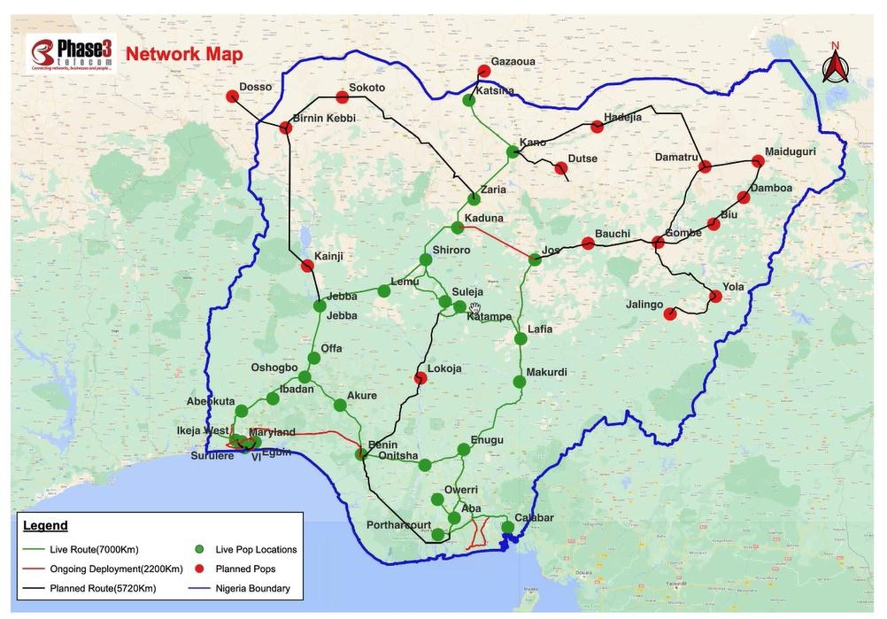

SCOPE OF WORK

In line with our understanding of Nigerian Midstream And Downstream Petroleum Authority (NMDPRA)l, “PHASE 3 Telecom Limited” is positioned to deliver dedicated, fullduplex internet connectivity to any office location across Nigeria. Our advanced transmission equipment ensures scalable, state-of-the-art speeds ranging from E1 to STM-n. With our dedicated broadband, we seamlessly connect businesses and communities to the world without limitations.

Details of our services, coverage, clientele, and additional information about Phase 3 Telecom are
available in the attached brochure and on our website: www.phase3telecom.com.

For further inquiries or discussions regarding this proposal, please do not hesitate to contact the undersigned.

Please accept the assurances of our highest consideration sir.

Yours faithfully,
for: Phase 3 Telecom Limited

Ukwueze Uzoamaka Christine,
Sales Executive
4, Yedseram Street,
Maitama,
Abuja.
Tel: +2348142061916
E-mail: uzoamakaukwueze@phase3telecom.com

